**Dalworth Rug Cleaning Website Effectiveness Recommendations**

**Homepage**

The overall design is nice and works well for fine rug services. However, the links for the two side doors are not clear, and valuable real estate is taken up by this design. Consider removing the two side doors to allow the text content to be in a higher position.

A very rough mockup is shown below

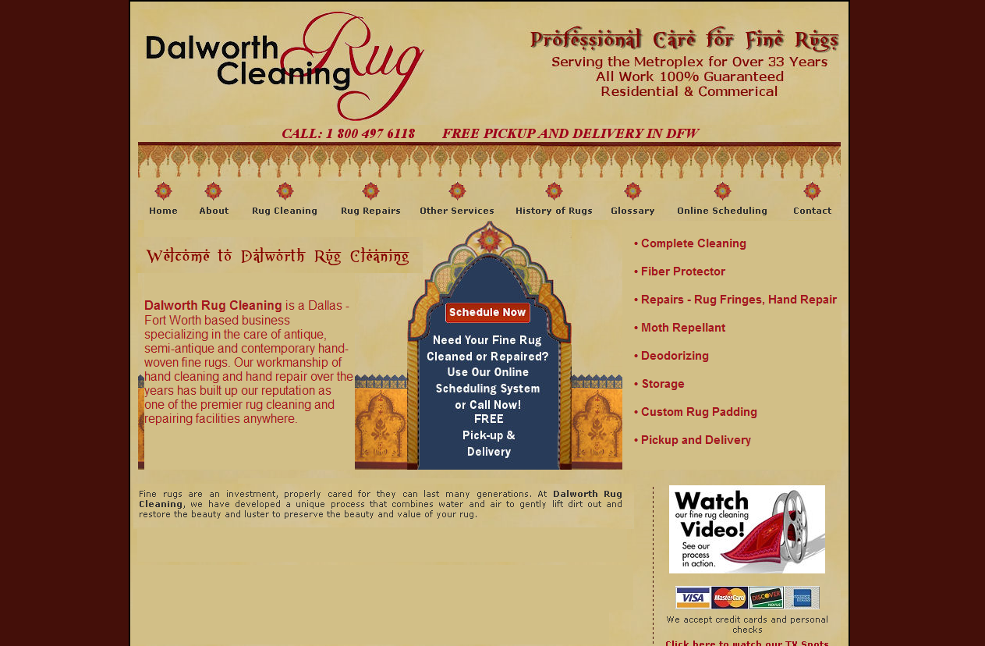

**Calls to Action**

The current calls to action are phone contact and a pickup scheduling form. Consider adding additional low-commitment web forms. “Request a quote” would be a useful form if you can provide quotes based on basic information. If that is not possible, a basic contact form for people to use to ask questions might be helpful for visitors who are interested, but not ready to commit to an appointment.

The online scheduling form is straightforward and does not have excess fields.

**Contact Page**

The contact page is more confusing with many different calls to action. This page should be simplified to have a brief contact form for questions or quotes, the main phone numbers, and the information for dropping off rugs.

The information for dropping off rugs should also contain the days and hours that you are open, and whether they need to make an appointment first, or if they can just drop by.

**About Us Page**

The bolding and capitalization of “Dalworth Rug Cleaning” in the About us page is distracting.

Also, consider revising this information to be more concise. Although people will want to know enough about the company to trust that their heirloom rugs will be taken care of properly, a few short paragraphs would be more powerful than the current explanation.

**Favicons**

Many visitors will be using tabbed browsing, and might move to a different tab and plan to go back to your page later. Having an icon in the tab will make it easier for them to find your tab. These small icons are called favicons. Be sure to create an image that will look good even when very small.

**Videos**

Videos are a great way to engage visitors. You have clever and professional ads that are promoted on a few pages directly, but usually only have a link that says “Click here to watch our TV spots”. Having a small still image of the video, especially an intriguing image and tagline like “Ankle Party” will draw more interest than a text link.

The informational videos are also high quality, but the calls to action are less noticeable. Rather than having a black box with small text underneath asking the visitor to click the play button, have a still image of the video with a large, clickable play symbol in the center, similar to YouTube. This more familiar format will attract more attention.